Critical Analysis - bit.ly/3UOioNy

Name | Kolin Thazhathupuram
Date | 23/004/2026
Student No | S00256832
Student Email | S00256832@atu.ie

Critical Analysis - see slides here
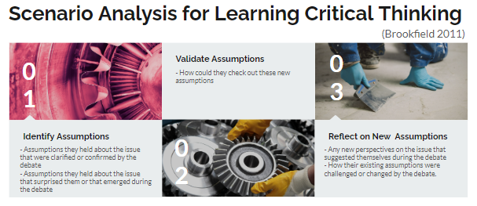
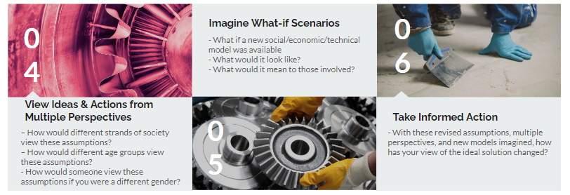

What *effect* does your system have?

On individuals?
On an individual level, it can improve focus, study habits, and self-awareness(it’s kind of like meditative learning which can also improve attention span). On a social level, it can support quieter shared spaces and more productive learning environments, especially in schools and libraries.

On society?
People would have more mental clarity, attention span would increase and better habits will develop in the process, overall having a transformative effect on society as a whole in a positive manner.

Future versions could help with wellness by monitoring temperature, sleep related conditions, or stress related environmental factors.

IoT health and wellness research shows that on device sensing and personalized alerts can support better everyday decisions.

1. Identify Assumptions
What assumptions did you make in designing your IoT system?
1. People in society especially with all the distractions these days need something to keep themselves in check.
2. Assuming the target audience which will need it most will be students/ a demographic in the younger age bracket.
3. Users want real-time feedback, not just stored data.
4. Noise is one of the most important distraction signals in the first prototype(the one we want to mainly put our emphasis and focus on)
5. The device should be affordable and easy to install with Arduino hardware.
6. Alerts should be simple, like a buzzer, LED, or phone notification.
7. The system should work locally first, because that is easier and reduces dependence on cloud services

2. Validate Assumptions
How could you check whether these assumptions are true?
1. Do market research by asking people in the target audience about their opinion on our product by conducting short surveys or interrogations at gunpoint if deemed necessary.
2. Test the prototype for factors such as, does the sensor detect noise accurately, is the threshold too sensitive or not enough, will the advice given by the IoT device be easily understandable by the user, do the alerts arrive quickly enough to actually help in real time.
3. Record the data and from there decide whether the assumptions were true or not.

3. Reflect on New Assumptions
What new insights have you gained by identifying and validating your assumptions?
1. Found out that the product isn’t a one fit for all solution as some users feel more distracted by the presence of the device itself rather than be helped by it.
2. Realised that noise is not the only major distraction, many users reported that their phones or digital notifications are a bigger issue, meaning the system may need to expand beyond just sound detection.
3. Learned that users have different tolerance levels for alerts; some prefer subtle feedback (like LEDs), while others are okay with stronger alerts (like buzzers), so customization is important.
4. Discovered that real time feedback is useful, but only if it is accurate and not overly sensitive, too many false alerts can frustrate users and make them ignore the system.
5. Found that ease of setup is more important than expected, if the Arduino system is too complicated to install, users are less likely to use it consistently.

4. Consider Different Perspectives
How does your IoT system design, ideas & actions look from Multiple Perspectives e.g. perspective people of different ages, different socio-economic backgrounds, different genders, different types of business people, different types of investors, different nationalities, differently abled people etc?
1. Younger users (students) may find the system helpful for studying, but older users or professionals might see it as unnecessary or intrusive, especially if they already have established focus habits.
2. Users with lower income may find even a low cost Arduino setup too expensive or difficult to access, while higher income users might prefer more polished, commercial alternatives instead of a DIY style device leading again to customisation being needed.
3. Some users may have different daily routines or responsibilities (e.g. shared spaces, caregiving), meaning constant alerts or noise detection might not suit their environment.
4. Students may benefit from strict alerts and reminders, while professionals might prefer more subtle or customizable feedback that doesn’t interrupt meetings or work calls.
5. Investors might question whether the product is scalable and unique enough compared to existing apps (like focus timers), and whether people would actually pay for a physical distraction-management device.
6.Users with hearing impairments may not benefit from sound-based alerts (buzzers), and users with sensory sensitivities may find alerts overwhelming, meaning accessibility features (visual cues, vibration, adjustable intensity) are important.

5. Imagine What-if Scenarios
Can you reimagine your IoT system, or the environments and people using, it to unlock new creative possibilities? What do you imagine could be possible in the future?
1. The system could evolve from just detecting distractions to actively improving the user’s environment. For example, it could connect to smart home devices to automatically adjust room temperature, lighting, or noise levels based on the user’s activity (studying, sleeping, relaxing), creating an optimal focus environment.
2. It could integrate with smartphones or computers to detect digital distractions (like excessive app usage) and respond by limiting notifications or suggesting breaks.
3. The device could use AI in the future to learn individual user habits and personalize feedback, becoming more like a smart assistant that adapts to each person’s focus patterns.

6. Take Informed Action
Having gone through this Critical Analysis exercise, what would you change about your system and why?
1. I would redesign the physical appearance of the device to make it look more professional and less toy like, as the current “cute robot” design may reduce its perceived seriousness and usefulness, especially for older users.
2. I would add customization options (e.g. adjustable alert types and sensitivity) because testing showed that different users respond differently to distractions and feedback.
3. I would consider adding more types of distraction detection (not just noise), since users are often distracted by multiple factors like phones or notifications.
4. I would improve accessibility by including multiple feedback methods (visual, vibration, and sound) so the system can be used by a wider range of people.

